**Project Design Phase-II Data Flow Diagram & User Stories**

|  |  |
| --- | --- |
| Date | 13/08/2022 |
| Team ID | PNT2022TMID12337 |
| Project Name | Smart Waste management in metropolitan cities. |
| Maximum Marks | 4 Marks |

# Data Flow Diagrams:

* A Data Flow Diagram (DFD) is a traditional visual representation of the information flows within a system. A neat and clear DFD can depict the right amount of the system requirement graphically. It shows how data enters and leaves the system, what changes the information, and where data is stored.
* A smart waste management platform uses analytics to translate the data gather in your bins into actionable insights to help you improve your waste services.
* You can receive the data metric such as;

The first test conducted is the situation where the garbage bin is empty or its garbage level is very low

Then, the bin is filled with more garbage until its level has surpassed the first threshold value,which is set to 80% then the first warning SMS is being sent, as depicted

The first notification SMS sent by the system,once the waste reaches the level of 85% full

The second notification SMS sent by the system,indicating that bins is at least 95% full and the garbage needs to be collected immediate

**DATA PHASE**

APP USER LOGIN

CONDITION OF BIN

**ACCESS** LOCATION OF FILLED BINS

# True

IF

# False

**GPS PHASE**

IDLE

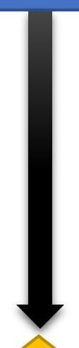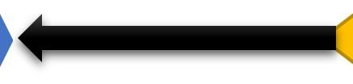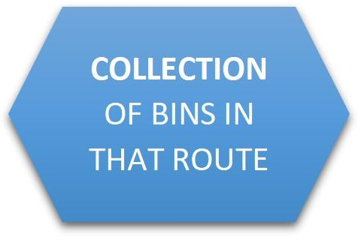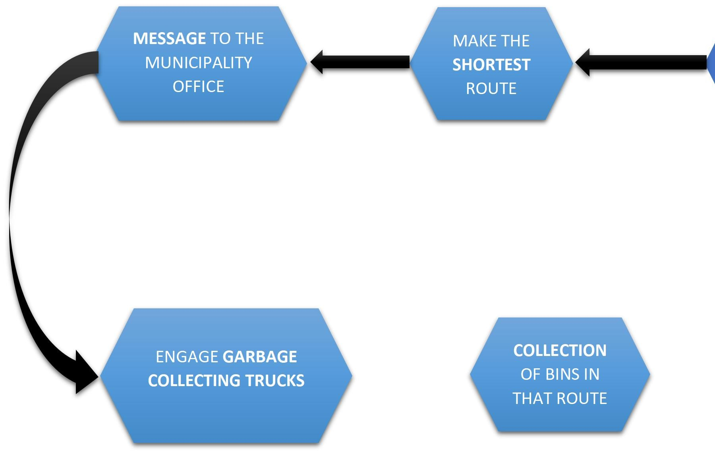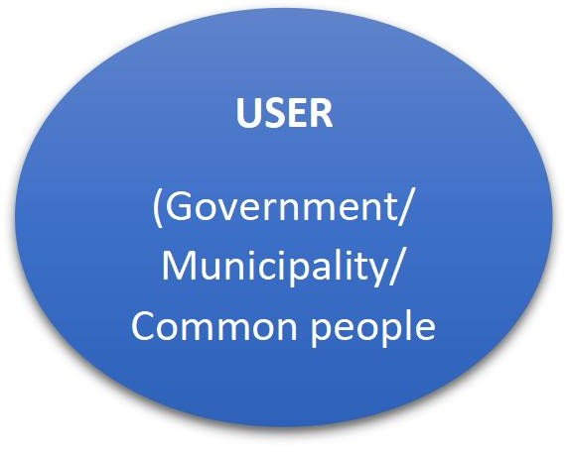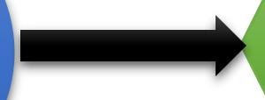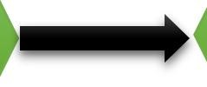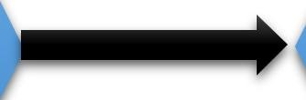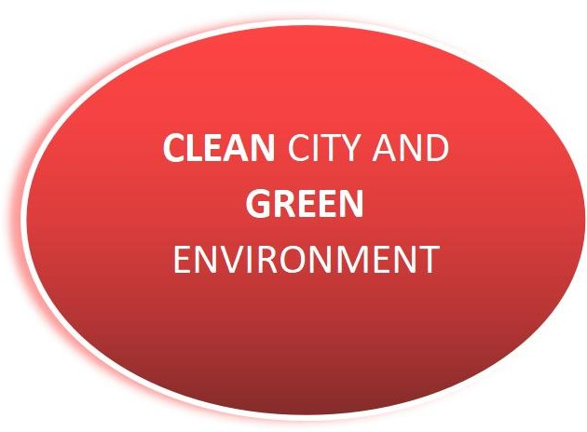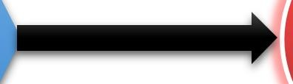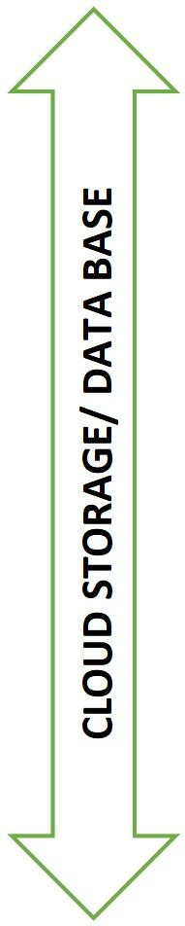

**COLLECTION PHASE**

**User Stories**

|  |  |  |  |  |  |  |
| --- | --- | --- | --- | --- | --- | --- |
| **User Type** | **Functional Requirement**  **(Epic)** | **User Story**  **Number** | **User Story / Task** | **Acceptance criteria** | **Priority** | **Release** |
| Customer (Mobile user) | Registration | USN-1 | As a user, I created an account in the  application provided. | I can access my account / dashboard | High | Sprint-1 |
|  |  | USN-2 | As a user, I registered  using my gmail. | I can receive  confirmation email . | High | Sprint-  1 |
|  |  | USN-3 | As a user, I successfully installed the app and login to see the bin level in  my area. | I can register & access the dashboard . | Low | Sprint-2 |
|  | Login | USN-4 | As a user, I login using my gmail and password easily. | The login process was easy and simple to access the dashboard. | High | Sprint-1 |

|  |  |  |  |  |  |  |
| --- | --- | --- | --- | --- | --- | --- |
| **User Type** | **Functional Requirement**  **(Epic)** | **User Story**  **Number** | **User Story / Task** | **Acceptance criteria** | **Priority** | **Release** |
| Customer (Web user) |  | WUSN-1 | As a web user I can see whether the bins in the locality arefilled or not only after loging in using  my gmail account. | The website must work properly so that no error occurs in the info. | High | Sprint-2 |
| Customer Care Executive |  | CCE-1 | A customer care executive will always be available for the interaction with the customer to clarify  the queries. | An executive will clarify the doubts and note down the complaints of the application if any . | High | Sprint-2 |
| Administrator |  | ADMIN-1 | I as a Admin can access the data or information provided by the customers to analyse their needs and provide the  required service. | The details of the locality of the user is provided to the municipal corporation when a complaint is  received. | High | Sprint-1 |